HILIC SOP on Opentrons Flex

(1-96 samples)
This protocol is written to process 50 µg protein with final digestion at 47°C for 1 hour with 2 µg trypsin. ** indicates adjustments where 25 µg protein is processed and digested with 1 µg trypsin. Protocol name on Opentrons Flex: SP3 HILIC protocol-New

Parameters
Name | Default | Range
Number of samples | 28 | 1-96
Reduction and Alkylation | On | On / Off
Incubation time | 1 hr | 1 hr / 2 hrs
Dry run | Off | On / Off

Fixed Parameters:
Incubation Temperature: 47°C
DTT working concentration: 110 mM
IAA working concentration: 360 mM
Protein amount: 50 µg in 50 µL
Reagent Plate type: Large plate 250 µL

Materials

- Opentrons Flex 96 Filter Tip Rack 200 µL (6 is the maximum, put at least X for XX samples) Deck Slots A3, B3, A4, B4, C4, D4

- ThermoFisher 96 well plate 250 µL lid in labware “Opentrons Tough PCR Auto-Sealing lid” Deck Slot C3

- Opentrons Tough 96 Well Plate 200 µL PCR Full Skirt samples Deck Slot A1

- Empty Opentrons Tough 96 Well Plate 200 µL PCR Full Skirt (>48 samples) OR
Opentrons 96 Aluminum Block with Generic PCR Strip 200 µL (>24 samples OR
Opentrons 24 Tuberack Eppendrof 1.5 ml Safelock Snapcap (<24 samples) final peptides Deck Slot B1

- Magnetic Block Deck Slot C1

- Universal HeatShaker Adaptor (flat, rectangular) change adaptors with purple star shaped screwdriver Deck Slot D1

- Empty ThermoFisher 96 well plate 250 µL for lysate-bead mixing Deck Slot A2

- NEST 96 Deep Well plate 2 mL Deck Slot B2

  - Formic Acid H12
  - Robot moved – DTT Column 4
  - Robot moved – IAA Column 5

- Opentrons 10 Tube Rack with Falcon 4x50 mL, 6x15 mL Conical Digestion buffer, DTT, IAA Deck Slot C2

- NEST 12 Well Reservoir 15 mL 10% Formic acid, Equilibration buffer, binding buffer, wash buffer Deck Slot D2

Notes
- PIPETTES LEFT: 1-channel 1000uL RIGHT: 8-channel 1000uL

- Samples at 50 µg in 50 µL volume (default 2% SDS, 50mM Tris pH 8) in Deck Slot A1 (Opentrons Touch 96 well plate 200 µL PCR Full Skirt).
Please see adjustments** if using 25 µg in 50 µL volume.

- HILIC beads need to be pre-washed with 2 x 200 µL Equilibration buffer (100mM Ammonium acetate, pH 4.5, 15% acetonitrile). Final beads should be placed in a 15 mL falcon tube in C3-position A1.

  - For 50 µg protein, 12.5 µL beads should be resuspended in 12.5 µL Equilibration buffer.
12.5*(# samples + 10) = bead amount, 12.5*(#samples+10) = final equilibration buffer
  - **For 25 µg protein, 6.25 µL beads should be washed and resuspended in 12.5 µL Equilibration buffer:
6.5*(# samples + 20) = bead amount to be washed
12.5*(#samples+20) = final equilibration buffer

- If processing >93 samples, reduction/alkylation needs to be done separately as there aren’t enough slots for tips.

  - If >93 sample and reduction/alkylation is needed, please run ReductionAlkylation protocol
    - You can still set up the deck as page 3, but you will need to add additional tips before running the SP3 HILIC protocol.
PAUSE point Once the lysate-bead is incubating, set your timer to 25 min. In the last 5 minutes, prepare your trypsin solution/digestion buffer. Once complete, hit pause on the Robot and place falcon tube in Slot C3, position A3.
PAUSE point There are pauses to move the lid before and after digestion incubation

Make sure to double check that everything is in the correct position. Refer to layout on next page.

If labware offsets are not present, perform a labware position check with the calibration probe to ensure no crashes occur.
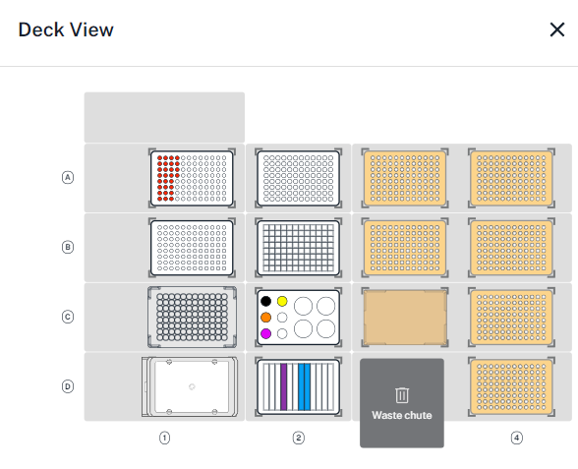
C2 - Opentrons 10 Tube Rack with Falcon 4x50 mL, 6x15 mL Conical
HILIC Bead Solution (15 mL falcon tube) 12.5 µl beads/sample, provide 12.5*sample#+125 µL for 50 µg protein.
* Beads should we equilibrated in tube before protocol begins
** For 25 µg protein, 6.25 µl beads is needed per sample, provide 6.25*samples#+125 µL.

Digestion Buffer (15 mL falcon tube) – 20 µg trypsin in 1 mL 50mM Tris pH 8 100 µL/sample, provide 100*sample#+ (50 µL*8). If using 25 µg** protein, resuspend 20 µg trypsin in 2 mL.
DTT Stock (15 mL falcon tube) – fixed 110 mM 5 µL/sample, provide 5*sample#+450 µL
IAA stock (15 mL falcon tube) – fixed 360 mM 5 µL/sample, provide 5*sample#+450 µL

D2 – NEST 12 well reservoir 15 ml
Formic Acid – 10% formic acid in water 10 µL/sample provide 10*sample#+1000 µL
- D2 – Column 1 (Maybe use a tube for small number of samples)
Binding Buffer – 200mM ammonium acetate, pH 4.5, 30% acetonitrile 60 µL/sample, provide 60*sample#+1000 µL
- D2 - Column 4
Wash Buffer – 95% acetonitrile (5% water) 300 µL/sample, provide 300*sample#+1000 µL
- D2- Columns 7 (and 8 for large volumes if sample#>45)

P200 tips (filter)
New 96 well plate, 200 ul PCR Full skirt
Thermofisher 96 well plate 250 ul
NEST 96 Deep well plate 2 ml
Lid
Samples
Magnetic Block
Universal Heat shaker adaptor
C2 - Opentrons 10 Tube Rack with Falcon 4x50 mL, 6x15 mL Conical
Prewashed HILIC Bead Solution (15 mL falcon tube) 12.5 µl beads/sample, for 50 µg protein 12.5 µl beads should be resuspended in 12.5 µl of Equilibration buffer. Make sure there is 125 µl extra final bead solution. **
Protein Buffer (50 mL falcon tube) – 2% SDS, 50mM Tris pH 8 only needed if diluting samples provide required volume + 1000 µL
Digestion Buffer (15 mL falcon tube) – 20 µg trypsin in 1 mL 50mM Tris pH 8 100 µL/sample, provide 100*sample#+ (50 µL*8). If using 25 µg** protein, resuspend 20 µg trypsin in 2 mL.
DTT Stock (15 mL falcon tube) – default 110 mM 5 µL/sample, provide 5*sample#+450 µL
IAA stock (15 mL falcon tube) – default 360 mM 5 µL/sample, provide 5*sample#+450 µL

D2 – NEST 12 well reservoir 15 ml
Equilibration Buffer – 100mM Ammonium acetate, pH 4.5, 15% acetonitrile 300 µL/sample, provide 300*sample#+1000 µL
Binding Buffer – 200mM ammonium acetate, pH 4.5, 30% acetonitrile 60 µL/sample, provide 60*sample#+1000 µL
Wash Buffer – 95% acetonitrile (5% water) 300 µL/sample, provide 300*sample#+1000 µL 300*sample#+1000 µL

